

A Project Report on

**Automatic Water Dispenser Using Arduino**

*Submitted in partial fulfillment of the requirement for the course*

**CS533 – INTERNET OF THINGS**

SUBMITTED BY

VISHAKA VINOD (1760412)

BHAVYA (1760436)

SHRISHTI PATIDAR (1760438)

PRACHI SAJWAN (1760468)

SUBMITTED TO

Dr. RAVINDRANATH CHOUDHARY

**Department of Computer Science and Engineering**

Faculty of Engineering,

CHRIST(Deemed to be University),

Kumbalgodu, Bangalore - 74.

September 2019.

A Project Report on

**Automatic Water Dispenser Using Arduino**

***Submitted in partial fulfillment of the requirement for the course***

#### **CS533 – INTERNET OF THINGS**

SUBMITTED BY

VISHAKA 1760412

BHAVYA 1760436

SHRISHTI 1760438

PRACHI 1760468

**Faculty-In-Charge Examiner Head of the Department**

**Department of Computer Science and Engineering**

**Faculty of Engineering,**

**CHRIST(Deemed to be University), Kumbalgodu, Bangalore - 74.**

**September 2019.**

**ABSTRACT**

About 71% of the earth is secured with water, yet 2.5% of it is drinking water. With ascend in population, contamination and environmental climate change, it is normal that by 2025 we will encounter water deficiencies.

On the off chance that we supplant all the manual taps with a brilliant one that opens and closes without anyone's help, we can spare water as well as have a more beneficial and advanced way of life. Therefore we making an Automatic Water Dispenser using Arduino and DC water pump that can give us water when a glass is brought close to it. We are using the remaining water after filtration to quench the thirst of animals and birds. The waste water pipe will be attached to a bowl and the bowl will have a sensor which will detect movements of animals. It will fill the bowl whenever it goes below a certain level and accordingly allows the water to flow.

**CONTENTS**

* Introduction
* Design/ Implementation

Architectural Design

Pin Diagram

Overall Design

* Components used
* Testing/ Result and Analysis

Result

Flowchart

* Conclusion and Future Scope
* References
* Sample Code
* Screenshots

**I**

**NTRODUCTION**

The objective of this project is to design and implement a water dispenser as well as an automatic monitoring and filling water bowls for pets.

The water dispenser provides easy access to clean, drinking water from a replaceable bottle. It allows a small vessel like a glass or bottle to be automatically filled when it is brought close to the dispenser.

Our project also enables the automatic refilling of the water bowls for pets. The pet owners need not constantly worry about refilling the water bowls of their pets as the water level is monitored and filled automatically.

**DESIGN AND IMPLEMENTATION**

**Architectural diagram:**

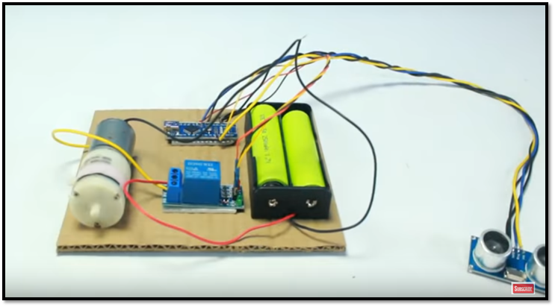

In our project we are using 5V dc water pump, 9V battery, relay, ultrasonic sensor, arduino uno board, USB cable to connect the arduino to laptop and jumper wires.

**Pin Diagram:**

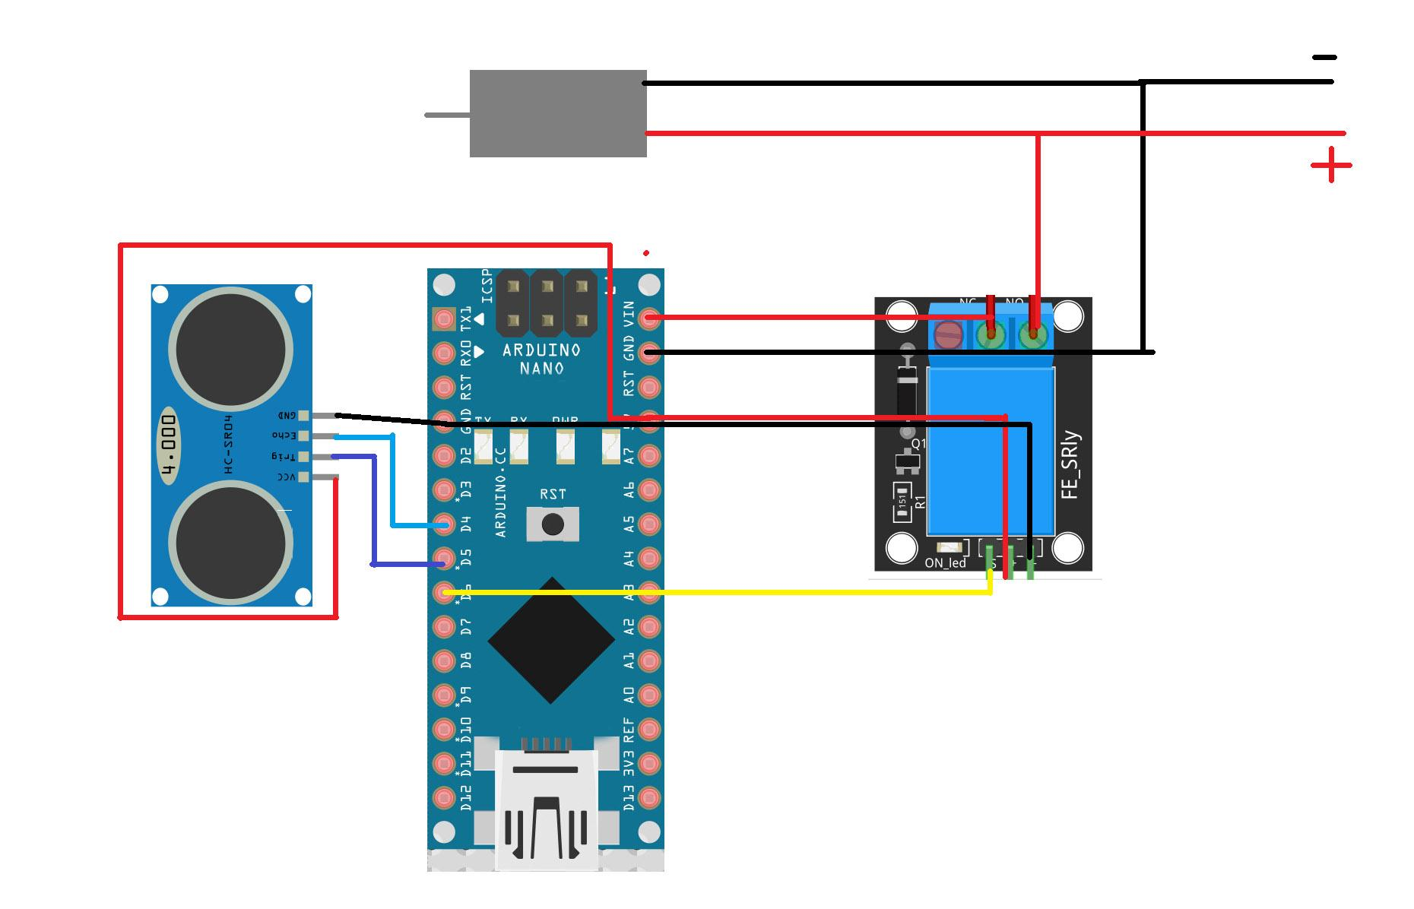

Starting with the ultrasonic sensor, vcc and ground of ultrasonic is connected to vcc and gnd of relay. Trigger and echo of ultrasonic is connected to d5 and d4 of arduino respectively.

Coming to relay, Vin of relay is connected to d6 of arduino. NO and COM of relay are connected to gnd and Vin of arduino. Negative of water pump is connected to negative of battery and gnd of arduino and positive of water pump is connected to positive of battery and Vcc of arduino.

**Overall Diagram:**

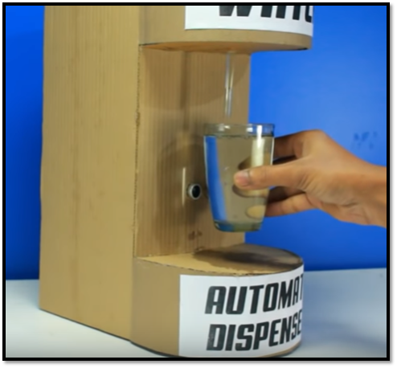

**COMPONENTS USED**

1. Ultrasonic Sensor: This sensor is used to detect the distance between the dispenser and the glass. It is also used to monitor the water level of the pet bowl and the distance of the pet from the bowl.
2. Relay: these are switches that open and close circuits electro mechanically or electronically. In this we are using, relay to control the flow of water i.e. we are controlling dc water pump.
3. Dc Water Pump:

The water pump consists of a DC motor that helps to pump water. In this project the pump helps to transfer water from the tank within the water dispenser to the glass as well as the pet bowl.

1. Arduino Uno: arduino uno board is used to easily connect hardware and software. It is used to read and write inputs and outputs.
2. Breadboard: In this project, we are using a basic breadboard to connect the components and complete the circuit.
3. Battery: gives power to dc water pump to work in the circuit.
4. Jumping wires: This component is used to connect all the components. The have connector pins on either ends of the wire. These can be male, female or hybrid pins.
5. Connecting wires: they are used to connect components and allows the flow of current within the circuit.
6. USB Cable: this cable is used to connect the Arduino Uno to the laptop or computer so that the code can be uploaded into the arduino.
7. Water level Sensor: Level sensors are used to detect the level of substances that can flow. Such substances include liquids, slurries, granular material and powders. Level measurements can be done inside containers or it can be the level of a river or lake.

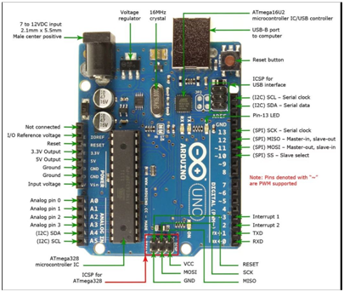

**ARDUINO UNO**

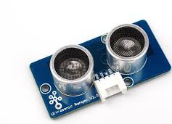 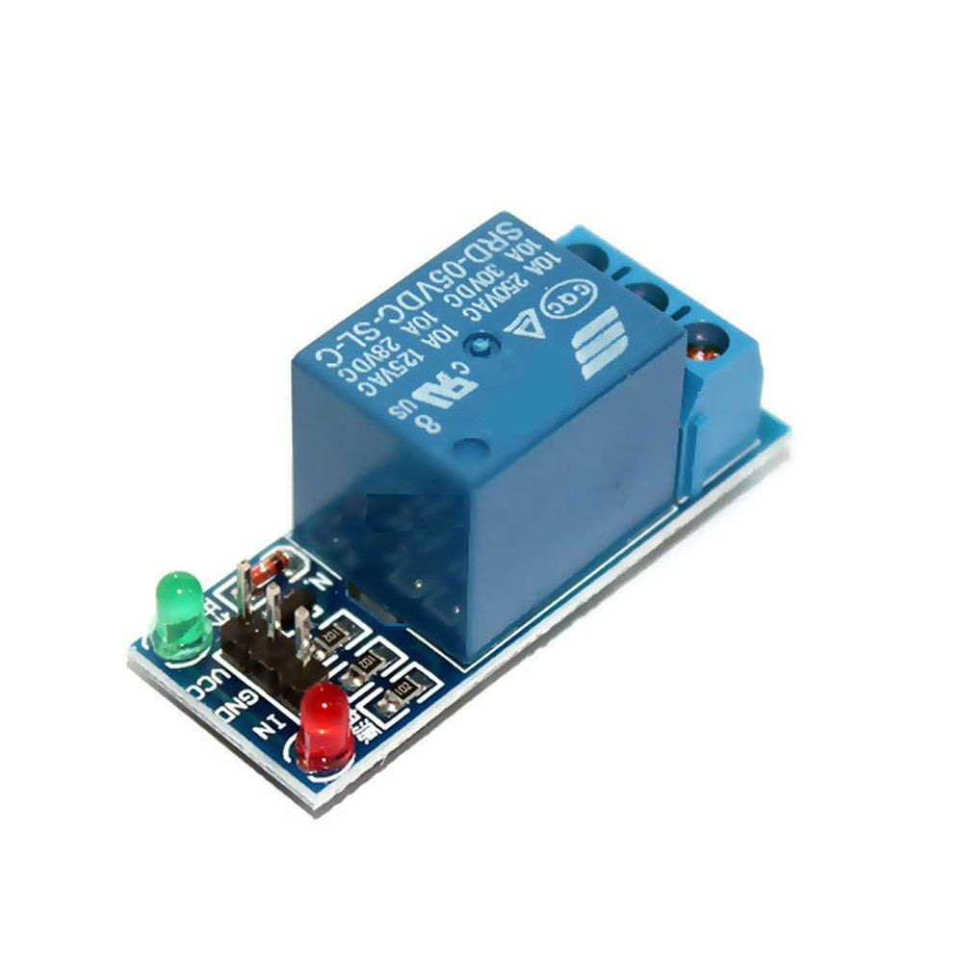

**ULTRASONIC SENSOR RELAY**

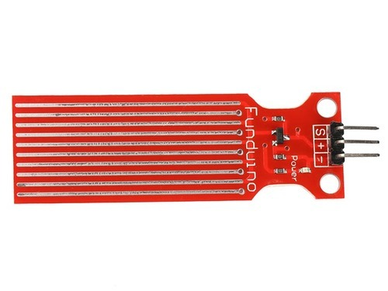

**WATER LEVEL SENSOR**

**TESTING AND ANALYSIS**

This project is divided into two parts:

1. The water pipe is attached to pet bowls. Whenever the water inside the pet bowl goes below a certain level, the water automatically starts filling the bowl. If a pet is near the bowl then the ultrasonic sensor detects the pet and the water is stopped for the time being. As soon as the pet moves away, the water starts filling it again.
2. The water pipe is attached to a dispenser which has an ultrasonic sensor that measures the distance between the dispenser and the glass. If the glass is in its range, it starts pouring water into it, otherwise nothing happens.

**FLOWCHART**

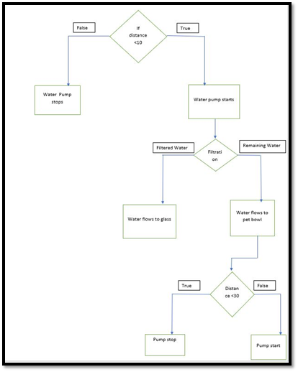

**CONCLUSION AND FUTURE WORK**

The system is suitable to be used in home activity contributing to the decrease of the energy consumption due to the water spills. Moreover, it can help people analyze the water consumption.

This project prevents unnecessary wastage of water, energy and time. It is suitable for use at home, schools, offices and can also be placed in private rooms.

Future work for this project includes attaching a water monitoring sensor to the dispenser for detecting the water level of the glass so that even when the person filling the glass is not looking, the water won’t overflow from the glass. Another thing that can be done is that the water that has been in the water tank of the reservoir for more than a week can automatically be transferred to the pet bowls.

**REFERENCES**

1. <https://www.tutorialspoint.com/arduino/arduino_dc_motor.htm>
2. <https://www.researchtrend.net/ijet/pdf/21-S-803.pdf>
3. <https://www.robomart.com/blog/working-of-hc-sr04-ultrasonic-sensor-with-arduino-uno/>
4. <https://www.youtube.com/watch?v=uJ9r2lP-ARA>
5. <https://www.instructables.com/id/Interfacing-Ultrasonic-Sensor-With-Arduino-1/>
6. <https://www.youtube.com/watch?v=jeJyLKhF3Xs>
7. <https://www.allaboutcircuits.com/projects/control-a-motor-with-an-arduino/>
8. <https://create.arduino.cc/projecthub/Isaac100/getting-started-with-the-hc-sr04-ultrasonic-sensor-036380>
9. <https://www.youtube.com/watch?v=N4qKZc5cuvo>

**SAMPLE CODE**

**Code for dispenser**

const int trigPin = 12;

const int echoPin = 13;

// defines variables

long duration;

int distance;

void setup() {

pinMode(trigPin, OUTPUT); // Sets the trigPin as an Output

pinMode(echoPin, INPUT); // Sets the echoPin as an Input

Serial.begin(9600); // Starts the serial communication

pinMode(8,OUTPUT);

}

void loop() {

// Clears the trigPin

digitalWrite(trigPin, LOW);

delayMicroseconds(2);

// Sets the trigPin on HIGH state for 10 micro seconds

digitalWrite(trigPin, HIGH);

delayMicroseconds(10);

digitalWrite(trigPin, LOW);

// Reads the echoPin, returns the sound wave travel time in microseconds

duration = pulseIn(echoPin, HIGH);

// Calculating the distance

distance= duration*0.034/2;

// Prints the distance on the Serial Monitor

Serial.print("Distance: ");

Serial.println(distance);

if(distance < 10){

digitalWrite(8,HIGH);

}

else{

digitalWrite(8,LOW);

}

}

**Code for pet bowls**

const int trigPin = 12;

const int echoPin = 13;

// defines variables

long duration;

int distance;

void setup() {

pinMode(trigPin, OUTPUT); // Sets the trigPin as an Output

pinMode(echoPin, INPUT); // Sets the echoPin as an Input

Serial.begin(9600); // Starts the serial communication

pinMode(8,OUTPUT);

}

void loop() {

// Clears the trigPin

digitalWrite(trigPin, LOW);

delayMicroseconds(2);

// Sets the trigPin on HIGH state for 10 micro seconds

digitalWrite(trigPin, HIGH);

delayMicroseconds(10);

digitalWrite(trigPin, LOW);

// Reads the echoPin, returns the sound wave travel time in microseconds

duration = pulseIn(echoPin, HIGH);

// Calculating the distance

distance= duration*0.034/2;

// Prints the distance on the Serial Monitor

Serial.print("Distance: ");

Serial.println(distance);

if(distance < 10){

digitalWrite(8,HIGH);

}

else{

digitalWrite(8,LOW);

}

}

**SCREENSHOTS**

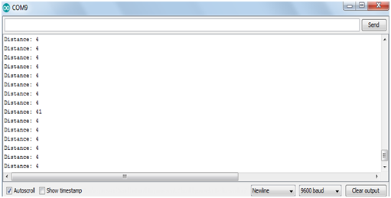

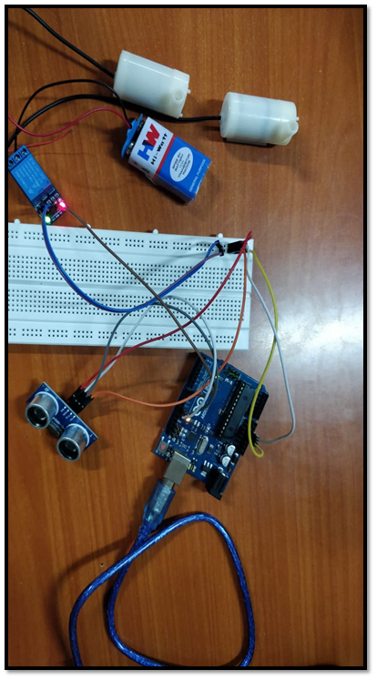

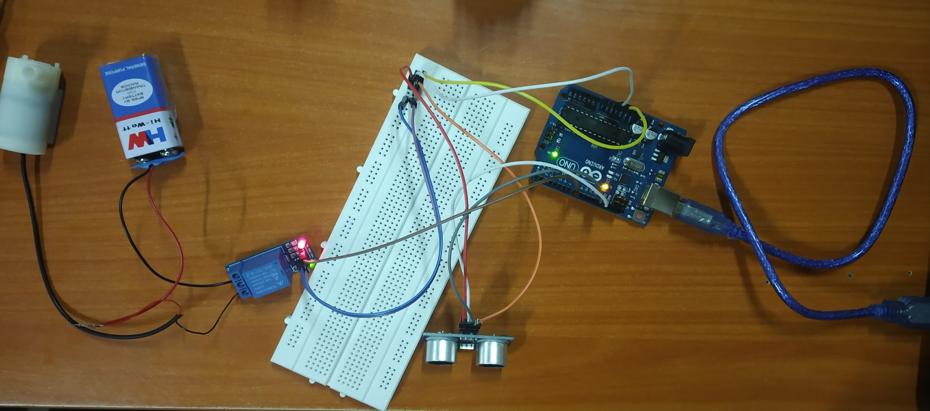

***THANK YOU***